
_________________________________________________________________________________

MAMC01803 Analytics for Managers
Assignment 2 - Report
_________________________________________________________________________________
Study Block 1 |  |  | 10th February – 11th April, 2025
Date issued
Due date |  |  | 7th April (Monday W9) |  |  | Time |  | Before 9:00 AM
Delivery: |  |  | Submit to Turnitin via Moodle before deadline
Weighting |  |  | 70%
Marks out of |  |  | 30
Instructions |  |  | Complete this cover sheet and attach to you your assignment.  - This assignment must be your own work.  - Collusion, copying or plagiarism may result in disciplinary action.  - We advise that you keep a copy of this assignment.  - Word limit is 3000  Refer to following website for reference related resources:  https://studentservices.op.ac.nz/assets/Uploads/OP-APA-7th-quick-guide-May-2020.pdf
I confirm that:
This is an original assessment and is entirely my own work.
Where ideas, tables, diagrams etc. of other writers have been used, I have acknowledged the source in every case.
This assignment has not been, nor will be, submitted as assessed work for any other academic course.
 | Student’s Name |  |  | ID No |  |  | Signature
 | Gielo Joseph Fernandez |  |  | 737214696 |  |  | Gielo
 | Date | March 24, 2025 |  |  | Cohort Number |  |  |  | 1

Table of Contents
1. INTRODUCTION 1
2. IBM EMPLOYEE ATTRITION DATASET 2
2.1 Table of categorization of variables into categorical or nominal along with the description of the variables 2
3. Business Problems 3
3.1 Identifying and analysing factors affecting attrition rate in a company 3
3.2 Identifying and Analysing Factors that affect Job Satisfaction in a company 9
3.3 Identifying and Analysing Factors that affect Work Life Balance in a company 10
4. Conclusion 10
5. References 11

1. INTRODUCTION
In the HR world, analytics in human resources have been around for years, as far as 1900s, traces of notion of measurement in human resources can be found (Marler & and Boudreau, 2017). So what is HR Analytics? HR analytics is by using statistical methods to integrate HR, talent management, financial, and operational data to create insights on how investments in human capital assets contribute to key business outcomes such as generating revenue, minimizing expenses, mitigating risks, and executing strategic plans (Lalwani, 2025).
This report aims to analyse an HR department of a big company in management of workforce, with a focus on handling employee retention, job satisfaction, and work-life balance. Using different types of analytics method, and with the support of relevant and recent articles, this report showcases how HR management can leverage analytics methods to make confident data driven decisions that is supported by data.
This dataset was selected from Kaggle (Ghate, 2020). From this dataset, we identified problems relating to factors affecting attrition, work-life balance, and job satisfaction. We used the 4 different analytics techniques (Descriptive, Diagnostic, Predictive, Prescriptive) along with journal articles to analyse the dataset.
Section two discusses the dataset that will be used in this report. Section three discusses the three business problems identified, as well as analyses done and recommendation. Lastly, Section four concludes the report and provides the limitation of the study.

2. IBM EMPLOYEE ATTRITION DATASET
A dataset is an organized collection of data. The most basic representation of a dataset is data elements presented in tabular form. Each column represents a particular variable. Each row corresponds to a given value of that column’s variable (Pecherskiy, 2016). Each column is categorised into numerical or categorical data. Then it is further categorised into the four levels of measurement: nominal, ordinal, interval and ratio. These levels are used to categorize and describe data based on their characteristics and properties (Stevens, 2023).
This dataset is about the employee attrition of IBM employees which were created by IBM data scientists, which was sourced from Kaggle (Ghate, 2020). The dataset consists of over 23436 rows, and 37 columns. This dataset can be used to address real world issues such as employee attrition, work life balance, job satisfaction, etc..
Regarding data cleaning the following steps were executed. First, rows that contained empty values were removed. Second, rows that had misaligned values or values that contained data from a different column were removed. Third, rows, that contained values ‘Test’ were removed as well. Since we have columns that contained categorical values, we needed to coded them into numerical values so that we can do clustering or prescriptive analytics. After data cleaning, we are left with 10005 rows for data analyses.
For data coding, the table below shows the equivalent numerical value based on the categorical representation.
Table 1
Data Coding
Variables | Coding
Attrition | 0 = 'Current Employee', 1 = 'Voluntary Resignation'
Overtime | 0 = 'No', 1 = 'Yes'
Duration At Company | 0 = '0-2', 1 = '3-4', 2 = '5-6', 3 = '7-8', 4 = '9-40'

2.1 Table of categorization of variables into categorical or nominal along with the description of the variables

Table 2
Variables and description
Variables | Type of Data | Type of Measurement
Attrition | Categorical | Nominal
Overtime | Categorical | Nominal
Duration At Company | Categorical | Ordinal
Job Satisfaction | Categorical | Ordinal
Hourly Rate | Numerical | Ratio
Work Life Balance | Categorical | Ordinal
Relationship Satisfaction | Categorical | Ordinal

Table 3
Variable description
Variables | Description
Attrition | whether the employee has left the company or is still employed . (0 = 'Current Employee', 1 = 'Voluntary Resignation)
OverTime | Indicates whether the employee works overtime (e.g., Yes, No). 0 = 'No', 1 = 'Yes'
Duration At Company | Years of duration of stay of the employee in the company (0 = '0-2', 1 = '3-4', 2 = '5-6', 3 = '7-8', 4 = '9-40')
Job Satisfaction | The employee's satisfaction with their job (1 = 'Low', 2 = 'Medium', 3 = 'High', 4 = 'Very High')
Hourly Rate | hourly rate of pay for the employee
Work Life Balance | The employee's perception of their work-life balance (1 = 'Bad', 2 = 'Good', 3 = 'Better', 4 = 'Best').
Relationship Satisfaction | The employee's satisfaction with their relationships at work (1 = 'Low', 2 = 'Medium', 3 = 'High', 4 = 'Very High').

3. Business Problems

3.1 Identifying and analysing factors affecting attrition rate in a company

How much does it cost when an employee decides to leave the company? According to Kennedy (2023), data from Work Institute estimates that each lost employee cost the company, on average, one third of their annual salary. Gallup puts the value even higher, placing the value of a satisfactory replacement employee as equal to one-half to two times the original employee’s salary. This value could be interpreted in various ways, such as the value that the employee brings to the company, cost to train the employee, cost to replace the employee, cost to hire and train the replacement, etc.. As a result, if your business is struggling with employee retention, it can significantly affect your bottom line and damage your company's brand in the process.
So what makes an employee decides to resign? Quality of work life, professional development, working hours, individual/family reasons, connection with coworkers, welfare, working conditions, compensation, were discovered as the main reasons for resignation (Basariya & Ahmed, 2019). High turnover due to these factors can negatively impact organization image, recruitment cost, company productivity, making employee retention a critical challenge for business (Hassan et al., 2019).
In this analyses, the variables attrition, overtime, duration at company to address the relationship between them.
In descriptive analytics, vertical bar charts are good at showing comparisons between 2 variables with less than 10 columns (Murray, 2019). Vertical bar chart can be an effective tool in comparing current employees vs employee who resigned. By creating a pivot table with rows as attrition and columns as whether they did overtime, and showing the output as percentage of total because it is more easier to read than the number of employees. An easy to read bar chart can be created using the pivot table.
Figure 1 below shows the pivot table of overtime and attrition.
Figure 1
Attrition and Overtime % pivot table
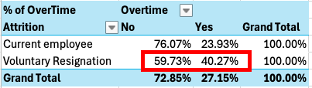
Based on the pivot table above, we can create a bar chart to represent the numbers better.
Figure 2
Attrition and Overtime Chart
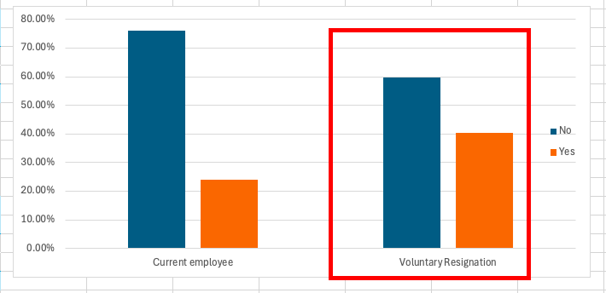
The vertical bar chart from figure 2 shows that a little over 40% of the employees who resigned did overtime unlike the current employees where only over 20% of them did overtime. This shows a disparity between current and resigned employees and indicates that employees who do overtime are likely to resign. A similar study conducted by Fallucchi et al. (2020), showed that among workers who worked overtime, the percentage of attrition is over 30%, while employees who did not work overtime only have an attrition rate of 10.4%.
For managers, this means that overtime could be a key driver of employee turnover. To improve retention, the company could consider strategies as long term planning and addressing understaffing (Hassan et al., 2019).
‘Duration at company’, like overtime, showed relationship with attrition. The figure below shows the pivot table.
Figure 3
Duration at company and attrition pivot table
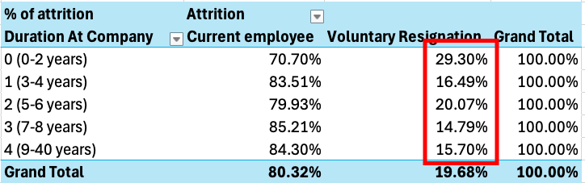
Based on the pivot table above, we can create a bar chart to represent the numbers better.
Figure 4
Duration At Company and Attrition bar chart
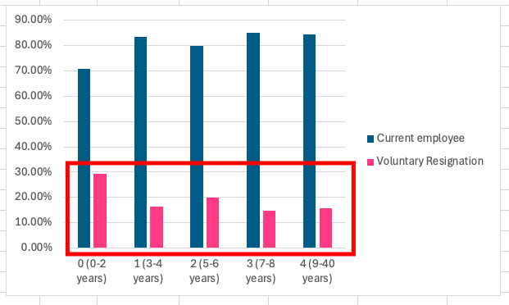
The figure 4 above shows the relationship between attrition and years at the company. The data shows that there is a large gap, as resignation between employees who are quite new to the company reached almost 30% attrition rate, while employees who reached 3 or more years in the company only has around 17% attrition rate on average. This indicates that the retention plan for new employees could need more improvement and support.
Aside from descriptive analytics, we can also use diagnostic analytics to see if there is a trend or correlation between variables. This is useful in supporting decisions with data (Cote, 2021). In this case we can use it to see if there is a connection between attrition rate and employee overtime.
Chi-square test, a type of diagnostic analytics method, is best used when comparing categorical data to check for null hypothesis (Nigam, 2022). In this case, Chi-Square test can be a good indicator in checking whether there is correlation between attrition and overtime. First we create the observed value table. Then we create expected value table, then we calculate for the Chi-square using the 2 tables.
The figure below shows the result of the Chi-Square Test.
Figure 5
Overtime and Attrition Chi-Square Test

Observed
% of overtime | Overtime
Attrition | No | Yes | Grand Total
Current employee | 6114 | 1923 | 8037
Voluntary Resignation | 1177 | 793 | 1970
Grand Total | 7291 | 2716 | 10007
Expected
Count of Overtime | Overtime
Attrition | No | Yes | Grand Total
Current employee | 0 | 0 | 0
Voluntary Resignation | 0 | 0 | 0
Grand Total | 0 | 0 | 0
Chi-Square Test | 2.64E-48

The value of Chi-Square test is shown in the figure 5 above, and since The p value(2.64E-48) is less than 0.05, we can reject the null hypothesis and conclude that there is significant relationship between overtime and attrition. For managers, this means that there is a strong statistical evidence linking overtime to attrition.
Figure 6
Chi-Square Test using Duration At Company and Attrition
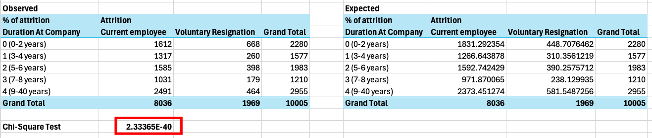
Although ‘Duration At Company’ is not categorical per se, it is now categorical since we grouped the values. This makes Chi-Square Test a valid method for this. The value of Chi-Square test is shown in the figure 4 above, and since The p value(2.33365E-40) is less than 0.05, we can reject the null hypothesis and conclude that there is significant relationship between duration at company and attrition. For managers, this means that there is a strong statistical evidence linking employee duration at company to attrition.
Using predictive analytics, we can use historical data to forecast future scenarios or identify the likelihood of something happening (Edwards & Olavsrud, 2025). In this case we can use it to predict the likelihood of an employee resigning in relation to overtime. The predictive analytics method that will be used in this scenario will be the logistic aggression as it is best used in predictive analytics when the outcome is limited to two possible outcomes: yes/no, 0/1, and true/false (Kanade, 2022).
By setting up attrition as the dependent variable, and the overtime as the independent variable. The figure below shows the result of logistic regression using Rapidminer.

Figure 7
Logistic Regression result of Overtime and Attrition in RapidMiner
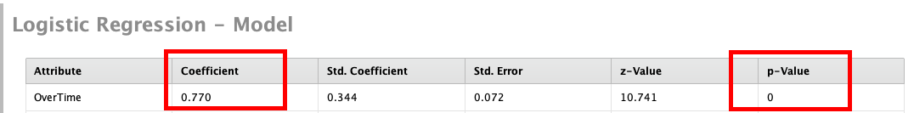

Figure 8
Logistic Regression result of Overtime and Duration At Company in RapidMiner
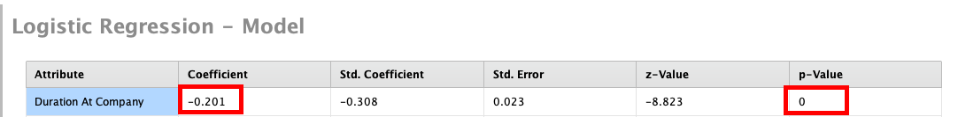
The figure 7 above shows the P-Value and the Coefficient results of logistic regression between Attrition and Overtime. The P-value result (0) shows that since it is less than 0.05, there is statistical significance between Attrition and Overtime. The Coefficient value signifies two things, first is that since it is greater than 0, there is a positive relationship between Attrition and Overtime. It means that as the does overtime, the risk of resigning increases. Second is that we can compute for the probability using the figure 12 below.
For the figure 8 above, there is also statistical significance between ‘Duration At Work’ and Attrition (0 < 0.05). However for the coefficient, we cannot say that there is negative relationship between duration at work and attrition because the attrition is not in a downward trend in figure 2. Therefore calculating for the probability will not make any sense.
Figure 9
Logistic Regression Accuracy(Attrition and Overtime
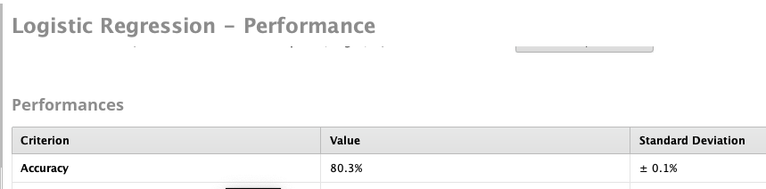
Figure 10
Logistic Regression Accuracy(Attrition and Duration At Company
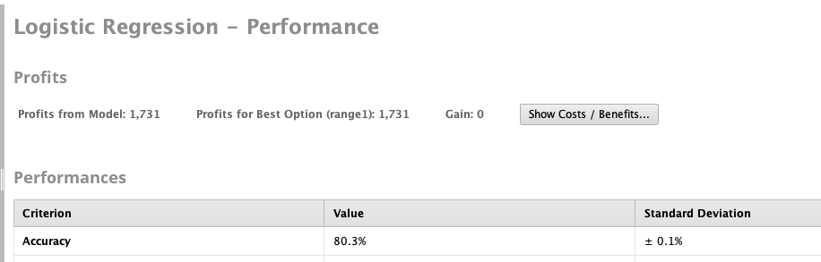
Regarding the accuracy of the logistic regression, the accuracy of both tests are above 80% as shown in figure 9 and 10.
Figure 11
Probability Formula (TIBCO Software Inc., 2025)
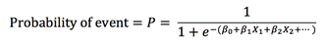
Using the formula in figure 11, we can calculate for the probability of an employee resigning when they do overtime.
Figure 12
Probability Calculation
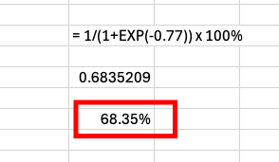
According to the calculation, there is almost 69% of employee resigning when they do overtime. Regarding the analytics methods used, descriptive analytics is a good representation as it does show the trend of what happened to the previous and current employees. Diagnostic analytics is also good at finding correlation and supporting the descriptive analytics, however both focus on past event and not focusing on current or future events. Predictive analytics is also good at predicting future events, however they require quality data to make good prediction (Balali et al., 2020). In this case, predictive analytics would make better prediction if overtime hours is included in the dataset.
As a manager of a team in this company, one thing that can be done is have accurate planning to properly estimate effort needed so the overtime can be avoided or lessened. Although there is no significant relationship between overtime and work-life balance in this study, overtime has a linear relationship various stress responses such as irritability, fatigue, anxiety, depression, and somatic responses (Kikuchi et al., 2020). Focus on training and development, social support, work-life balance, compensation, development opportunities and autonomy could address employee retention of new employees of the company (Kossivi et al., 2016). According to one study, slower learning rate was attributed to employee retention as there is mutual benefit from both employee and company (Kwon & and Yoo, 2017).

3.2 Identifying and Analysing Factors that affect Job Satisfaction in a company
(800-900 words):
The definition and significance of the problems (use appropriate intext references).
Mention the relevant variables and data types used to solve the problem (use intext references to justify the use of the variables). Tell me why did you choose these variables and how can it help solve the problem.
Mention the data analysis techniques and methods that you will use to solve the problem, provide justification for using the data analysis methods (support the justification of using the methods with appropriate intext references).
Perform the data analysis and provide appropriate results such as graphs, tables, screenshots related to the analysis.
Interpret the analysis results and tell me what the results mean for the organisation/manager.
Provide future recommendations for solving the problem and address the strengths and limitations of the analysis methods (back the recommendations and strengths/limitations with intext references).

3.3 Identifying and Analysing Factors that affect Work Life Balance in a company
(800-900 words):
The definition and significance of the problems (use appropriate intext references).
Mention the relevant variables and data types used to solve the problem (use intext references to justify the use of the variables). Tell me why did you choose these variables and how can it help solve the problem.
Mention the data analysis techniques and methods that you will use to solve the problem, provide justification for using the data analysis methods (support the justification of using the methods with appropriate intext references).
Perform the data analysis and provide appropriate results such as graphs, tables, screenshots related to the analysis.
Interpret the analysis results and tell me what the results mean for the organisation/manager.
Provide future recommendations for solving the problem and address the strengths and limitations of the analysis methods (back the recommendations and strengths/limitations with intext references).

4. Conclusion
(150-200 words): summarize your 3 problems and analysis methods. try to identify and briefly talk about some limitations regarding your dataset in 1 or 2 sentences.

5. References

Balali, F., Nouri, J., Nasiri, A., & Zhao, T. (2020). Data Intensive Industrial Asset Management. https://doi.org/10.1007/978-3-030-35930-0
Basariya, R., & Ahmed, R. R. (2019). A Study on Attrition – Turnover Intentions of Employees. International Journal of Civil Engineering and Technology (IJCIET), 10(1), 2594–2601.
Cote, C. (2021). What Is Diagnostic Analytics? 4 Examples. HBS Online. https://online.hbs.edu/blog/post/diagnostic-analytics
Edwards, J., & Olavsrud, T. (2025). What is Predictive Analytics? Transforming Data into Future Insights. CIO. https://www.cio.com/article/228901/what-is-predictive-analytics-transforming-data-into-future-insights.html
Fallucchi, F., Coladangelo, M., Giuliano, R., & William De Luca, E. (2020). Predicting Employee Attrition Using Machine Learning Techniques. Computers, 9(4). https://doi.org/10.3390/computers9040086
Ghate, R. (2020). Capstone Project-IBM Employee Attrition Prediction [Dataset]. Kaggle. https://www.kaggle.com/datasets/rushikeshghate/capstone-projectibm-employee-attrition-prediction
Ghate, R. (2025). Capstone Project-IBM Employee Attrition Prediction [Dataset]. Kaggle. https://www.kaggle.com/datasets/rushikeshghate/capstone-projectibm-employee-attrition-prediction
Hassan, M., Jambulingam, M., Alam, M. N., & Islam, S. (2019). Redesigning the retention strategy against the emerging turnover of Generation Y: Revisiting the long-standing problems from 20Th to 21St century. International Journal of Entrepreneurship, 23(2), 1–16.
Kanade, V. (2022). What Is Logistic Regression? Equation, Assumptions, Types, and Best Practices. Spiceworks. https://www.spiceworks.com/tech/artificial-intelligence/articles/what-is-logistic-regression/
Kennedy, R. (2023). Focusing on the High Cost of Employee Turnover. Randstad New Zealand. https://www.randstad.co.nz/hr-news/attracting-recruiting-talent/focusing-high-cost-employee-turnover/
Kikuchi, H., Odagiri, Y., Ohya, Y., Nakanishi, Y., Shimomitsu, T., Theorell, T., & Inoue, S. (2020). Association of overtime work hours with various stress responses in 59,021 Japanese workers: Retrospective cross-sectional study. PloS One, 15(3), e0229506. https://doi.org/10.1371/journal.pone.0229506
Kossivi, B., Xu, M., & Kalgora, B. (2016). Study on Determining Factors of Employee Retention. Open Journal of Social Sciences, 4, 261–268. https://doi.org/10.4236/jss.2016.45029
Lalwani, P. (2025). What Is HR Analytics? Definition, Importance, Key Metrics, Data Requirements, and Implementation. Spiceworks. https://www.spiceworks.com/hr/hr-analytics/articles/what-is-hr-analytics/
Marler, J. H., & and Boudreau, J. W. (2017). An evidence-based review of HR Analytics. The International Journal of Human Resource Management, 28(1), 3–26. https://doi.org/10.1080/09585192.2016.1244699
Murray, E. (2019). Why Do Bar Charts Work? Forbes. https://www.forbes.com/sites/evamurray/2019/04/04/why-do-bar-charts-work/
Nigam, V. (2022). T-Test vs. Chi-Square Test: Differences and When to Use Each. Built In. https://builtin.com/data-science/t-test-vs-chi-square
Pecherskiy, M. (2016). What Is A Dataset? A Delicious Explanation. https://medium.com/quandary-dot-io/what-is-a-dataset-a-delicious-explanation-81ca1723c227
Stevens, E. (2023). 4 Levels of Measurement: Nominal, Ordinal, Interval & Ratio. https://careerfoundry.com/en/blog/data-analytics/data-levels-of-measurement/
TIBCO Software Inc. (2025). Probability Calculation Using Logistic Regression. https://docs.tibco.com/pub/sfire-dsc/6.5.0/doc/html/TIB_sfire-dsc_user-guide/GUID-C4D05ED0-3392-4407-B62A-7D29B26DC566.html

